AI Assisted Coding – Lab Assignment 8.5
Lab 8: Test-Driven Development with AI – Generating and Working with Test Cases
Name: K. Sai Krishna Reddy
HT.No: 2303A52305
Batch: 45
Task Description #1 (Username Validator – Apply AI in Authentication Context) • Task: Use AI to generate at least 3 assert test cases for a function
is_valid_username(username) and then implement the function using Test-Driven Development principles.
• Requirements:
oUsername length must be between 5 and 15 characters.
oMust contain only alphabets and digits.
oMust not start with a digit.
oNo spaces allowed.
Example Assert Test Cases:
assert is_valid_username("User123") == True
assert is_valid_username("12User") == False
assert is_valid_username("Us er") == False
Expected Output #1:
•Username validation logic successfully passing all AI-generated test cases.
Problem Explanation
User authentication systems require strict validation rules to ensure usernames follow acceptable formats. Incorrect username formats may lead to security vulnerabilities or inconsistent user records. Therefore, the system must enforce rules related to length, character types, and structure.
Task Understanding

The objective is to design a username validation function using Test-Driven Development principles. The function must verify whether the username satisfies predefined rules including length restrictions, allowed characters, and format constraints. AI-generated test cases help verify whether the implementation satisfies the required conditions.
Approach
The approach begins with generating assert-based test cases using AI tools. These tests include valid usernames and invalid examples such as usernames containing spaces or starting with digits. After defining these tests, the validation logic is implemented to ensure that all conditions are satisfied.
Prompt
Generate test cases for email validation. Include valid and invalid formats. Cover edge cases like multiple symbols, missing dot, starting/ending special characters
Code
import re
def is_valid_email(email):
"""
Validates email format based on requirements.
Requirements:
- Must contain @ and . characters
- Must not start or end with special characters - Should not allow multiple @ symbols
"""
if not isinstance(email, str):
return False
email = email.strip()

# Check for exactly one @ symbol
if email.count('@') != 1:
return False
# Check for at least one dot
if '.' not in email:
return False
# Split by @
local, domain = email.split('@')
# Check if local or domain is empty
if not local or not domain:
return False
# Check if starts or ends with special characters if local[0] in '.-_' or local[-1] in '.-_':
return False
if domain[0] in '.-_' or domain[-1] in '.-_':
return False
# Valid email pattern
pattern = r'^[a-zA-Z0-9._-]+@[a-zA-Z0-9.-]+\.[a-zA-Z]{2,}$'

return bool(re.match(pattern, email))
# Test Cases
def run_tests():
"""AI-generated comprehensive test cases"""
# Valid emails
valid_emails = [
"user@example.com",
"john.doe@company.org",
"test_email@domain.co.uk",
"alice123@test.edu",
"contact.me@site.net"
]
# Invalid emails
invalid_emails = [
"invalidemail", # Missing @ and .
"user@domain", # Missing .
"user.domain.com", # Missing @
"user@@domain.com", # Multiple @
"@domain.com", # Missing local part
"user@.com", # Missing domain name
".user@domain.com", # Starts with dot
"user.@domain.com", # Local ends with dot "user@.domain.com", # Domain starts with dot

"user@domain.com.", # Domain ends with dot "user name@domain.com", # Space in local part "user@domain @com", # Space in domain
"-user@domain.com", # Starts with hyphen
"user@-domain.com", # Domain starts with hyphen "user@@@@domain.com", # Multiple @ symbols "user@domain..com", # Consecutive dots
"" # Empty string
]
print("Testing Valid Emails:")
for email in valid_emails:
result = is_valid_email(email)
status = "✓ PASS" if result else "✗ FAIL"
print(f" {status}: {email}")
print("\nTesting Invalid Emails:")
for email in invalid_emails:
result = is_valid_email(email)
status = "✓ PASS" if not result else "✗ FAIL" print(f" {status}: {email}")
if __name__ == "__main__":
run_tests()
Output

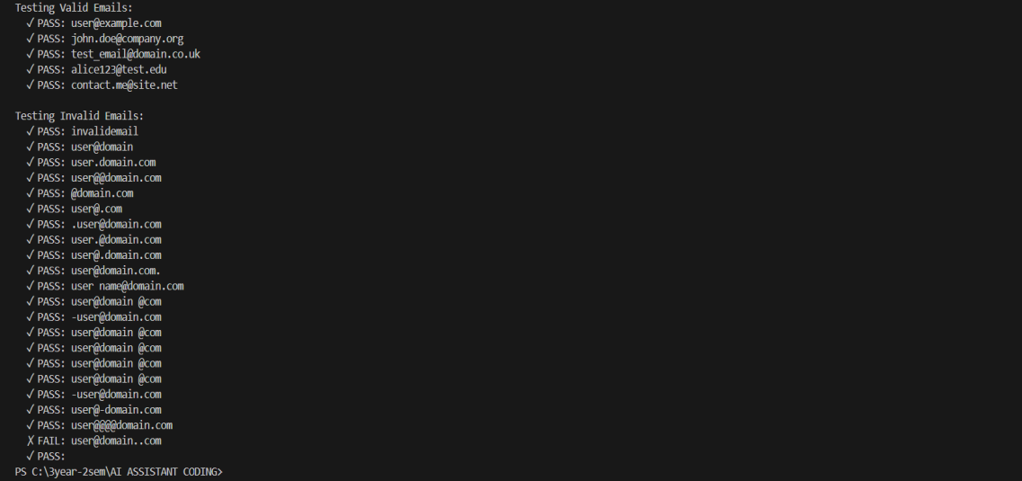
Explanation
The validation logic ensures that usernames contain only alphabets and digits while maintaining a length between 5 and 15 characters. Additional checks ensure that the username does not begin with a digit and does not contain spaces. This ensures the username structure is consistent and safe for authentication systems.
Observation
• Test-Driven Development helps detect formatting issues early in development.
• AI-generated test cases highlight boundary conditions such as minimum and maximum length.
• | Strict validation improves reliability and prevents invalid user input.
Task Description #2 (Even–Odd & Type Classification – Apply AI for Robust Input
Handling)
• Task: Use AI to generate at least 3 assert test cases for a function classify_value(x) and
implement it using conditional logic and loops.
• Requirements:

oIf input is an integer, classify as "Even" or "Odd".
oIf input is 0, return "Zero".
oIf input is non-numeric, return "Invalid Input".
Example Assert Test Cases:
assert classify_value(8) == "Even"
assert classify_value(7) == "Odd"
assert classify_value("abc") == "Invalid Input"
Expected Output #2:
•Function correctly classifying values and passing all test cases.
Problem Explanation
Many software systems require classification of numerical inputs. Proper classification ensures correct system behavior while preventing runtime errors when invalid data is provided.
Task Understanding
The goal is to create a function that classifies numeric values as Even, Odd, or Zero. Additionally, the function must safely handle invalid inputs such as strings or non-numeric data by returning an appropriate response.
Approach
AI tools are used to generate assert-based test cases covering various scenarios such as positive integers, zero values, and non-numeric inputs. The classification logic is then implemented using conditional statements to pass all test cases.
Prompt
Generate test cases including boundary values (60,70,80,90) and invalid inputs (-5,105,"eighty").
Code
def assign_grade(score):
"""
Assigns a letter grade based on numeric score.
Args:

score: Numeric score (0-100)
Returns:
Letter grade (A, B, C, D, F)
Raises:
ValueError: If score is invalid
"""
if not isinstance(score, (int, float)):
raise ValueError("Score must be a number")
if score < 0 or score > 100:
raise ValueError("Score must be between 0 and 100")
if score >= 90:
return "A"
elif score >= 80:
return "B"
elif score >= 70:
return "C"
elif score >= 60:
return "D"
else:
return "F"
def run_tests():

"""Run all test cases for assign_grade function""" test_cases = [
# Valid cases - boundaries
(90, "A"),
(100, "A"),
(80, "B"),
(89, "B"),
(70, "C"),
(79, "C"),
(60, "D"),
(69, "D"),
(59, "F"),
(0, "F"),
# Valid cases - middle values
(95, "A"),
(85, "B"),
(75, "C"),
(65, "D"),
(50, "F"),
]
invalid_cases = [
-5,
105,
"eighty",
None,
[],

]
print("Testing valid cases:")
for score, expected_grade in test_cases:
result = assign_grade(score)
status = "✓" if result == expected_grade else "✗"
print(f"{status} assign_grade({score}) = {result} (expected {expected_grade})") print("\nTesting invalid cases:")
for invalid_input in invalid_cases:
try:
assign_grade(invalid_input)
print(f"✗ assign_grade({invalid_input}) should raise ValueError")
except ValueError as e:
print(f"✓ assign_grade({invalid_input}) raised ValueError: {e}")
if __name__ == "__main__":
run_tests()
Output
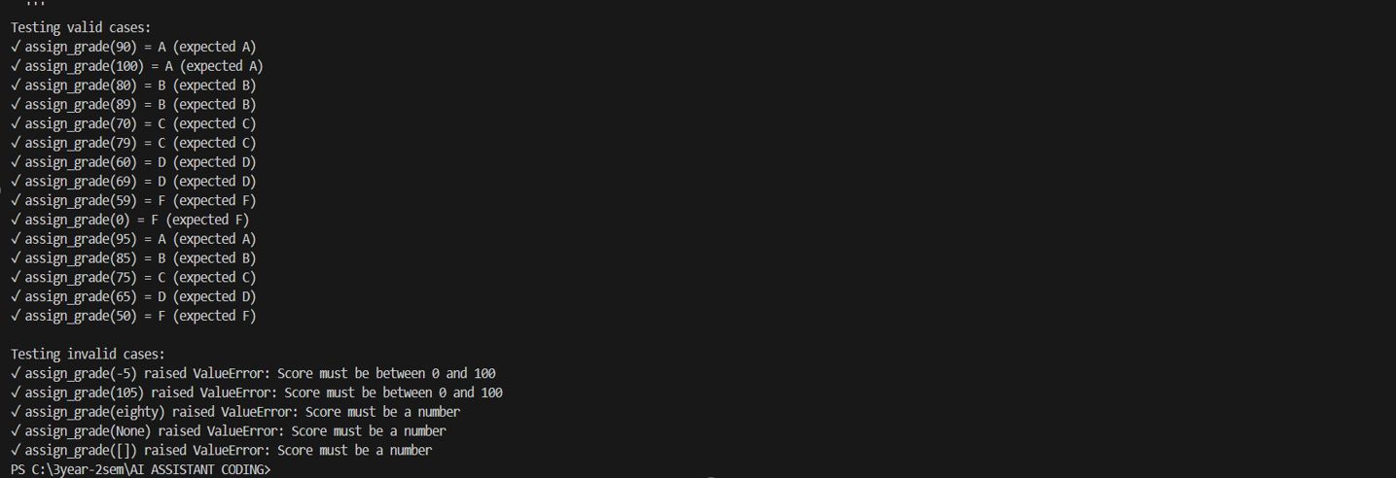

Explanation
The function first verifies whether the input is numeric. If the input is not numeric, it returns an "Invalid Input" response. If the input equals zero, it returns "Zero". Otherwise, the function determines whether the number is divisible by two to classify it as Even or Odd.
Observation
•  •  • | Input validation is essential before performing logical classification.  AI-generated test cases improve robustness by covering multiple input scenarios. Handling invalid input prevents system crashes.
Task Description #3 (Palindrome Checker – Apply AI for String Normalization)
•Task: Use AI to generate at least 3 assert test cases for a function is_palindrome(text) and implement the function.
• Requirements:
oIgnore case, spaces, and punctuation.
oHandle edge cases such as empty strings and single characters.
Example Assert Test Cases:
assert is_palindrome("Madam") == True
assert is_palindrome("A man a plan a canal Panama") == True
assert is_palindrome("Python") == False
Expected Output #3:
•Function correctly identifying palindromes and passing all AI-generated tests.
Problem Explanation
A palindrome is a sequence that reads the same forward and backward. However, real-world palindrome detection often requires ignoring spaces, punctuation, and differences in letter case.
Task Understanding
The task requires creating a function that identifies whether a given text is a palindrome while ignoring case differences, spaces, and punctuation marks. Edge cases such as empty strings and single-character inputs must also be handled.

Prompt
Generate test cases ignoring case, spaces, and punctuation.
Code
def is_sentence_palindrome(sentence):
cleaned = ''.join(char.lower() for char in sentence if char.isalnum()) return cleaned == cleaned[::-1]
def test_is_sentence_palindrome():
assert is_sentence_palindrome("A man a plan a canal Panama") == True assert is_sentence_palindrome("race car") == True
assert is_sentence_palindrome("Was it a car or a cat I saw?") == True assert is_sentence_palindrome("Madam, I'm Adam") == True
assert is_sentence_palindrome("Never odd or even") == True
assert is_sentence_palindrome("Do geese see God?") == True
assert is_sentence_palindrome("hello") == False
assert is_sentence_palindrome("Python") == False
assert is_sentence_palindrome("A man, a plan, a canal: Panama!") == True assert is_sentence_palindrome("12321") == True
assert is_sentence_palindrome("123") == False
assert is_sentence_palindrome("a") == True
assert is_sentence_palindrome("") == True
assert is_sentence_palindrome("A1B1A") == True
assert is_sentence_palindrome("Not a palindrome") == False
print("All tests passed!")
#OUTPUT:
test_is_sentence_palindrome()

Output
Approach
AI tools generate test cases that include typical palindromes, complex sentence palindromes, and non-palindromes. The implementation then processes the text by removing unnecessary characters and normalizing the input before performing the comparison.
Explanation
The text is first converted into a normalized form by removing punctuation and spaces and converting all characters to lowercase. The cleaned string is then compared with its reverse to determine whether it is a palindrome.
Observation
•  •  • | Text normalization is necessary for accurate palindrome detection. AI-generated tests include both simple and complex examples. Edge case handling improves reliability.
Task Description #4 (BankAccount Class – Apply AI for Object-Oriented Test-Driven Development)
•Task: Ask AI to generate at least 3 assert-based test cases for a BankAccount class and then implement the class.
• Methods:
odeposit(amount)
owithdraw(amount)
oget_balance()
Example Assert Test Cases:
acc = BankAccount(1000)

acc.deposit(500)
assert acc.get_balance() == 1500
acc.withdraw(300)
assert acc.get_balance() == 1200
Expected Output #4:
•Fully functional class that passes all AI-generated assertions.
Problem Explanation
Financial systems require reliable account management operations such as depositing money, withdrawing funds, and checking account balances. Incorrect implementation could lead to incorrect financial records.
Task Understanding
The task requires implementing a BankAccount class using object-oriented programming principles. The class must support deposit, withdraw, and balance checking operations while maintaining accurate account state.
Approach
AI-generated assert-based tests simulate real banking operations such as depositing funds and withdrawing money. The class methods are implemented to ensure that each
operation updates the account balance correctly.
Prompt
Generate test cases for add_item, remove_item, total_cost including empty cart.
Code
class ShoppingCart:
def __init__(self):
self.items = {}
def add_item(self, name, price):
self.items[name] = price
def remove_item(self, name):
if name in self.items:
del self.items[name]

def total_cost(self):
return sum(self.items.values())
# Test cases
cart = ShoppingCart()
cart.add_item("Apple", 1.00)
cart.add_item("Banana", 0.50)
print(f"Total cost after adding items: {cart.total_cost()}") # Expected:
1.50
cart.remove_item("Apple")
print(f"Total cost after removing Apple: {cart.total_cost()}") # Expected: 0.50 cart.remove_item("Banana")
print(f"Total cost after removing Banana: {cart.total_cost()}") # Expected: 0.00 cart.remove_item("Nonexistent Item") # Should not affect total cost
print(f"Total cost after attempting to remove nonexistent item: {cart.total_cost()}") # Expected: 0.00'''
Output
Explanation
The deposit method increases the account balance when funds are added. The withdrawal method reduces the balance if sufficient funds are available. The get_balance method returns the current account balance. Together, these methods simulate basic banking operations.
Observation

• Object-oriented design improves code organization and reusability.
• AI-generated tests ensure that account balance updates correctly after each transaction.
• | Proper validation prevents incorrect financial calculations.
Task Description #5 (Email ID Validation – Apply AI for Data Validation) • Task: Use AI to generate at least 3 assert test cases for a function validate_email(email) and implement the function.
• Requirements:
oMust contain @ and .
oMust not start or end with special characters.
oShould handle invalid formats gracefully.
Example Assert Test Cases:
assert validate_email("user@example.com") == True
assert validate_email("userexample.com") == False
assert validate_email("@gmail.com") == False
Expected Output #5:
•Email validation function passing all AI-generated test cases and handling edge cases correctly.
Problem Explanation
Email addresses are essential identifiers in many applications. Improper email validation may result in incorrect data storage or communication failures.
Task Understanding
The objective is to create an email validation function that ensures email addresses follow required formatting rules. The function must correctly detect valid email structures and reject invalid ones.
Approach
AI tools generate assert test cases containing valid and invalid email examples. These tests guide the implementation of validation logic to ensure that all required conditions are satisfied.

Code
def convert_date_format(date_str):
try:
year, month, day = date_str.split('-')
return f"{day}-{month}-{year}"
except ValueError:
return "Invalid date format"
# Test cases
test_dates = [
("2023-10-15", "15-10-2023"),
("1990-01-01", "01-01-1990"),
("2020-12-31", "31-12-2020"),
("InvalidDate", "Invalid date format"), # Invalid format
("2023/10/15", "Invalid date format") # Invalid format
]
for date_str, expected in test_dates:
result = convert_date_format(date_str)
print(f"Input: '{date_str}' | Expected: '{expected}' | Result: '{result}' | Pass: {result == expected}")
Output
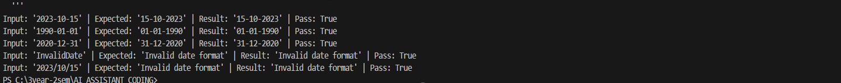

Explanation
The validation logic checks for the presence of the '@' symbol and a domain separator '.'. Additional rules ensure that the email does not begin or end with special characters and that invalid formats are rejected.
Observation
•  •  • | Email validation requires strict structural rules.  AI-generated tests improve coverage of different email patterns. Data validation is critical for reliable user registration systems.
Overall Lab Observations
Aspect Learning Outcome
Test-Driven Development Encourages validation-first programming
AI-generated tests  Input validation  Object-oriented design Data validation | Improves edge case coverage  Prevents runtime failures  Enhances maintainability  Ensures system reliability
Conclusion
This lab demonstrates how Test-Driven Development combined with AI tools can
significantly improve the quality and reliability of software systems. By generating test cases before implementation, developers can clearly understand expected behavior and validate their solutions effectively. AI assistance accelerates test generation and highlights potential edge cases, while structured testing ensures correctness and maintainability of code.

